9.4. CHANGE MANAGEMENT PROCEDURES FOR OFFICIAL TTUHSC WEB PAGES/SITES
Templates have been used to manage and maintain the web site layout and navigation. Within a web page, a specific command can be used that will insert the contents of another file (the include file) into that web page. This is especially useful when template components, such as headers, footers, and navigational elements, are the same on a number of pages throughout a Web site. Using include files allows a programmer to only modify the include file to change a template element, instead of updating every individual Web page. Include files have been used primarily to maintain consistent navigation.
The web design attempts to maintain a consistent navigation. To this end, much of the navigation has been integrated on related pages. Navigational integration exists in situations where a navigational set is deemed important enough to be repeated from page to page. An example of this is the integration of HSC resources and other global navigation into every page. At the department level,F integrated navigation exists for that department only. In order to manage and maintain the integrated navigation, include files have been utilized.
Within the templates, areas have been designated as “not editable” and “editable”. “Editable” areas are controlled by the appropriate content managers unless it is noted differently in this procedure. “Not editable” areas and include files that are used for integrated global navigation are controlled primarily by the Web Strategy Council and their appointed work groups unless it is noted differently in this procedure.
Development and Oversight
An integrated information environment that enhances education, research and patient care at TTUHSC requires resources dedicated to the development, implementation, and support of TTUHSC’s Web Presence. The development and oversight of TTUHSC’s Web Presence including the web sites, the portal, and content management will be under the leadership of the Web Strategy Council. One member will be appointed to the Web Strategy Council by the:
- President,
- Executive Vice President for Finance and Administration,
- Executive Vice President for Research,
- Senior Vice President for Academic Affairs,
- Vice President for Information Technology and CIO,
- Vice President for F. Marie Hall Institute for Rural and Community Health,
- Dean of the School of Allied Health Sciences,
- Dean of the TTUHSC School of Medicine,
- Dean of the Foster School of Medicine,
- Dean of the School of Nursing,
- Dean of the School of Pharmacy,
- Dean of the Graduate School of Biomedical Sciences
- Director of Communications and Marketing
- Assistant Vice President for Finance and Administration, Amarillo,
- Assistant Vice President for Finance and Administration, El Paso,
- Assistant Vice President for Finance and Administration, Permian Basin, and
- TTUHSC Student Government Association President.
The CIO or his designee will chair the Web Strategy Council. The Web Strategy Council will meet formally on an annual basis or more frequently at the call of the CIO or his designee. The Council will also meet electronically through the use of SharePoint or other methods to conduct business as needed. The Web Strategy Council will provide the leadership and expertise needed for TTUHSC to develop a coordinated web strategy. Under the direction of the CIO, the Council will serve as the advisory body reporting to the I.T. Board of Directors to:
- Define the goals and objectives for the web site,
- Create web policies and standards,
- Recommend procedures to ensure compliance with web policies and standards,
- Create a strategically integrated web environment for TTUHSC,
- Coordinate web activities throughout TTUHSC,
- Provide seamless access to information and services throughout the web domain,
- Provide direction and governance for the HSC Luminis Web Portal,
  - Recommend new HSC and Texas Tech channels and enhancements to the project prioritization committees
  - Recommend new HSC links
  - Evaluate other institutions’ Portals on an ongoing basis for content and usage ideas
  - Review and approve/deny requests for channels and links within the portal made by HSC entities
- Recommend appointments of specific content organization groups when needed,
- Approve Tier 2 and lower template designs,
- Define site development and maintenance responsibilities for TTUHSC web sites through the recommendation of appointments of content contributors and content managers for each department, school and campus,
- Establish design and content lifecycles, and
- Provide an Institutional approach to skills development and the acquisition of software tools.
The current lifecycles as approved by the Web Strategy Council on June 13, 2006 are:
- Design - The current structure and navigation will begin to be reviewed in 2 years.
- Content - All content will be reviewed at least yearly.
- Central Column - The middle content area on the Institutional home page, that includes the “From Here It’s Possible,” “Prepare for Your Future,” and “Make an Impact” areas, will be reviewed every 6 months.
Modifications To “Not Editable” Areas In All Templates
Modifications to the “not editable” areas of the templates are managed by the following process:
- Design is approved by the President’s Executive Council (PEC), the Web Strategy Council provides leadership in development and oversight, and Information Services maintains design and layout.
- The design of the web site will be reviewed on a recurring basis as defined by the Web Strategy Council.
Requests for possible modifications to the design or navigation must be submitted to the Web Strategy Council through the Associate Vice President of Information Services. Modification requests will be considered by the Web Strategy Council (WSC) as necessary. The modification requests that were accepted for approval by the WSC are referred to the PEC for final approval. All requests must be approved by the PEC prior to implementation.
Institutional And Campus Home Page Management - “Editable” Areas
The current web design for TTUHSC is based upon the zone layouts described in this section of the I.T. Policies.
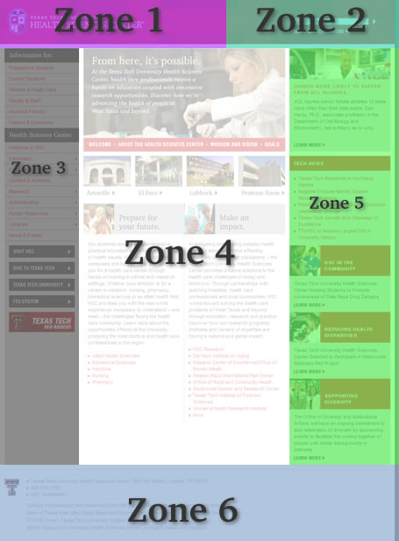
Because the Institutional and Campus home pages represent the entire TTUHSC community, quality assurance is necessary to retain the integrity of the Institution’s identity. Therefore, modifications to the “editable” areas on these pages are managed by the following process:
Zone 4 - “Prepare for Your Future” and “Make an Impact” and Zone 5 - News and Announcements and Features Areas
The Office of Communications & Marketing (OCM) at the Institution or the campus manages the information and marketing aspect of these areas. All text, photos, and links must be submitted to OCM for approval prior to posting.
All other zones contain “not editable” areas only:
Zone 1 - Logo
Zone 2 - Search
Zone 3 - Audience Menus and Health Science Center Menus
Zone 6 - Footer
Key Public Entry Point Page Management- “Editable” Areas
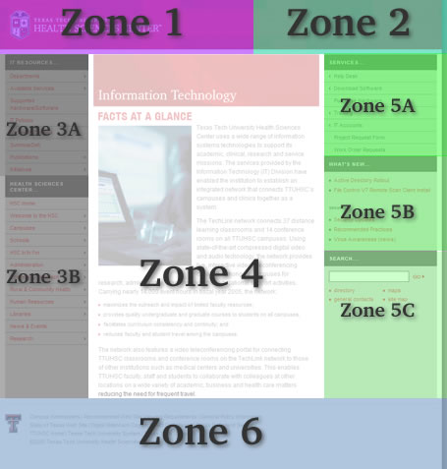
A key public entry point is defined as a web page that is specifically designed for members of the general public to access official Institution information. TTUHSC has designated the following as key public entry points:
- Audience home pages,
- School home pages, and
- Offices and other administrative areas.
Key public entry points represent high profile areas of the TTUHSC web, thus quality assurance is necessary to retain the integrity of the Institution’s identity. At these levels, upper level navigational elements are interconnected. The interlocking nature of this navigation ensures consistent and up-to-date access to high-profile information. Modifications to “editable” areas on key public entry points are managed by the following process:
- Zone 3A and 5A - Audience/School/Office or Administrative area navigation
  - Each entity is responsible for modifications to their navigation area.
- Zone 5B - Audience/School/Office or Administrative area Announcements or news
  - Each entity is responsible for modifications to their navigation area.
- Zone 4 - Entry Area
  - Each entity is responsible for managing the content of this area.
- All other zones contain “not editable” areas only:
  - Zone 1 - Logo
  - Zone 2 - Blank
  - Zone 3B - Audience Menus and Health Science Center Menus
  - Zone 5C - Search
  - Zone 6 - Footer
Sub Page Management - “Editable” Areas
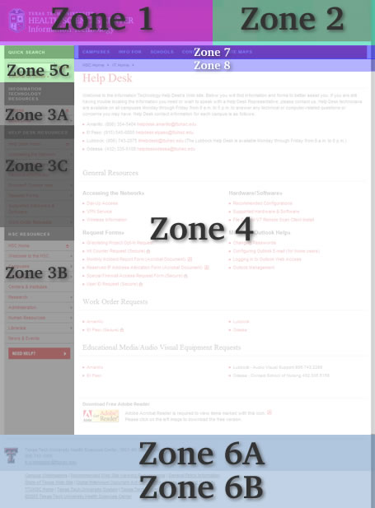
Because the sub pages are connected to their key public entry points, quality assurance is necessary to retain the integrity of the Institution’s identity and navigation. Modifications to the “editable” areas on sub pages are managed by the following process:
- Zone 3A & 3C - Audience/School/Office or Administrative area navigation
  - Includes entities such as Administration, Human Resources, Libraries, News & Events, and Research.
  - Each entity is responsible for modifications to their navigation area.
- Zone 4 –
  - This zone is reserved for the page content.
  - Content owners are responsible for maintaining the content of each sub page.
  - All content must comply with TTUHSC Operating Policies and Procedures and TTUHSC Identity Guidelines.
- Zone 6A –
  - This zone includes the contact information specific to that sub page.
  - The contact information portion of this zone is the responsibility of the content owner.
- Zone 7 –
  - This zone includes the Institutional global navigation. An entity may append to the end of the Contact Info and Site Maps lists with links to their respective contact information and site map.
- Zone 8 –
  - This zone is used for navigational breadcrumbs. HSC Home is built in the template to always appear as the first part of breadcrumb navigation on a sub page.
  - Subsequent links should reflect the hierarchy of preceding pages, but should never contain the link of the page being displayed.
- All other zones contain “not editable” areas only:
  - Zone 1 - Logo
  - Zone 2 - Blank
  - Zone 3B - Audience Menus and Health Science Center Menus
  - Zone 5C - Search
  - Zone 6B - Footer
General Process For Web Content Management
The purpose of web content management is to preserve the integrity of the TTUHSC web site while maintaining accurate and up-to-date subject matter.
Web management is about facilitating and encouraging the use of the web. This means finding a way to enable non-technical staff to publish web-based materials without too much effort, and yet ensuring quality content that will be useful and effective. Web content management addresses the following questions:
- Who has access to publishing on the web and how is access granted and managed?
  - The Deans, Vice Presidents, Chairs, and Department Heads will appoint content managers and identify content contributors for each campus, school, and department. Information Services will maintain a database of all individuals who have been granted access to contribute and manage content on the web. Information Services will also periodically monitor the compliance of the sites on the TTUHSC web to ensure that they are being maintained in a manner that maintains the integrity of the template design. Anyone not maintaining the integrity of the templates or making unauthorized changes to the design may have their access revoked. After the first or second occurrence, a warning will be sent out to the registered individual and retraining will be scheduled if needed. All access will be revoked upon the third occurrence. However, access may be revoked immediately with the approval of the CIO upon consultation with the appropriate Dean or Vice President.
- What type of materials can be published?
  - Generally, materials such as word docs, pdf’s, excel spreadsheets, text and images may be published. However, all content must comply with the standards set forth in this document and with the TTUHSC Operating Policies and Procedures.
- Who is responsible for content and maintenance?
  - Accountability for high quality content on TTUHSC web sites is a shared responsibility. Each academic or administrative unit will be required to develop and maintain high-quality, up-to-date, easily navigated content applicable to the purpose of the web page or site.
  - Designated content managers are responsible for maintaining accurate and up-to-date subject matter for web pages in their area.
  - Information Services will periodically conduct reviews to insure that web content and brand identity is being kept up to date. Content managers may be contacted in instances where it is noted that content has not been reviewed in the past 12 months. Sites and/or pages that are not regularly maintained are subject to removal. A removal notification will be sent out to the registered web publisher 30 days before the site and/or page is removed and a second notice will follow 10 days prior to the removal date. However, a site and/or page may be removed immediately with the approval of the CIO upon consultation with the appropriate Dean or Vice President.
- What tools are used to create and edit web content?
  - Non-technical content managers will use the content management system to create and edit web content.
  - Technical content managers can also use the content management system to create and edit web content. Alternatively, technical users are also allowed to use such tools as Adobe Dreamweaver, Visual Studio.Net, etc.to create and edit web content and/or develop applications.
  - All content managers will also be required to use the HSC Application Publisher for publishing a web application to production servers. For simple applications and web sites not in the content management system, alternative tools are provided for publishing to the test and production servers. Database driven applications or content will utilize Microsoft SQL Server databases. No other database systems (MS Access, mySQL, etc.) will be allowed on the production web environment without prior approval of the Associate Vice President of Information Services.
  - It is recommended that all application developers utilize a source code repository and versioning tool. Information Services utilizes Team Foundation Server for this purpose. Outside departments may utilize TFS by purchasing the applicable license for use with Visual Studio. For TFS licensing information, please contact Information Services.
- Training and technical support required?
  - Before content managers are given access to their site, they must be trained by Information Services on the following:
    - Use of the Content Management System.
    - Use of the HSC Application Publisher and the TTUHSC design templates. If other Information Services developed tools are used for publishing, then training will be required.
    - Use of the Microsoft SQL Server test and production environments, if used.
    - Use of the design CSS and properly applying style classes as defined in the design stylesheets.
    - Coding valid XHTML.
    - Complying with American Disability Act (ADA) standards.
    - Texas Administrative Code (TAC) compliance.
    - Information Services does not provide training on third party products such as Adobe Dreamweaver. Users who choose to use these products in lieu of the content management system are responsible for obtaining training and technical support from other sources.
- How do I make changes?
  - Definitions:
    - Test server - this is the server where all modifications are made and tested prior to moving them to the production server. The test server is only accessible from within the TTUHSC network (http://ou.ttuhsc.edu for the content management system).
    - Production server - this is the live, publicly accessible version of the web site (http://www.ttuhsc.edu)
  - All changes to web content are to be made and thoroughly tested on the Institutional test server.
  - All content managers must conduct the “Pre-Publishing Checks” listed below prior to publishing any content from test to production.
  - Access to content on the test servers and the ability to publish to the production servers will be controlled through authentication that utilizes eRaider.
- Pre-Publishing Checks
  - Before publishing a content modifier must:
    - Thoroughly review and test all changes using the test servers provided.
    - Verify that all links within the content are valid.
    - Spell check all pages.
    - Complete Security Code Review and Vulnerability testing with designated Information Services Staff.
- Before publication, validate the page using an acceptable tool or method for:
  - Accessibility
  - Valid HTML or XHTML coding
  - Valid CSS
  - Compliance with ADA standards
  - W3C
If unsure, please contact chris.barnard@ttuhsc.edu
Please note that these processes may change periodically as the TTUHSC web services mature and as movement is made toward a content management system.

