My Profile

  - User’s Manual

Version 11.02

Contents
Introduction 2
My Account 3
Profile 3
Change Password 6
Biosketch, CV, Pubs 7
Training History 9
Medical Licenses 9
Signature 11
Notes 11
Announcements 13
Operating Procedures 14
View Correspondence 15
All Department Reports 16
Department Reports 17

My Profile

Introduction
The My Profile menu group in iRIS™ is available to all users. It contains various components of your account information, announcements, operating procedures, and a variety of other helpful items (depending on how your system is configured). It is located at the top right section, next to the log out button.
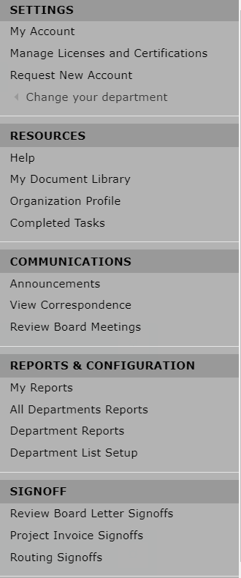

My Account
My Account allows users to quickly access and update personal information, change passwords, look up training history, medical licenses or CVs, upload a .jpg image of the users signature (used when signing off on Outcome letters), set signoff ability, view vaccination history etc.. The availability of these tabs is dependent on how your system is configured; do not be alarmed if your screen is missing one or more menu items. Some screenshots may also vary depending on what features are turned on or off and whether any labels have been renamed by your System Administrator.
When you first click on the My Account link, a new page will open listing your personal contact information.
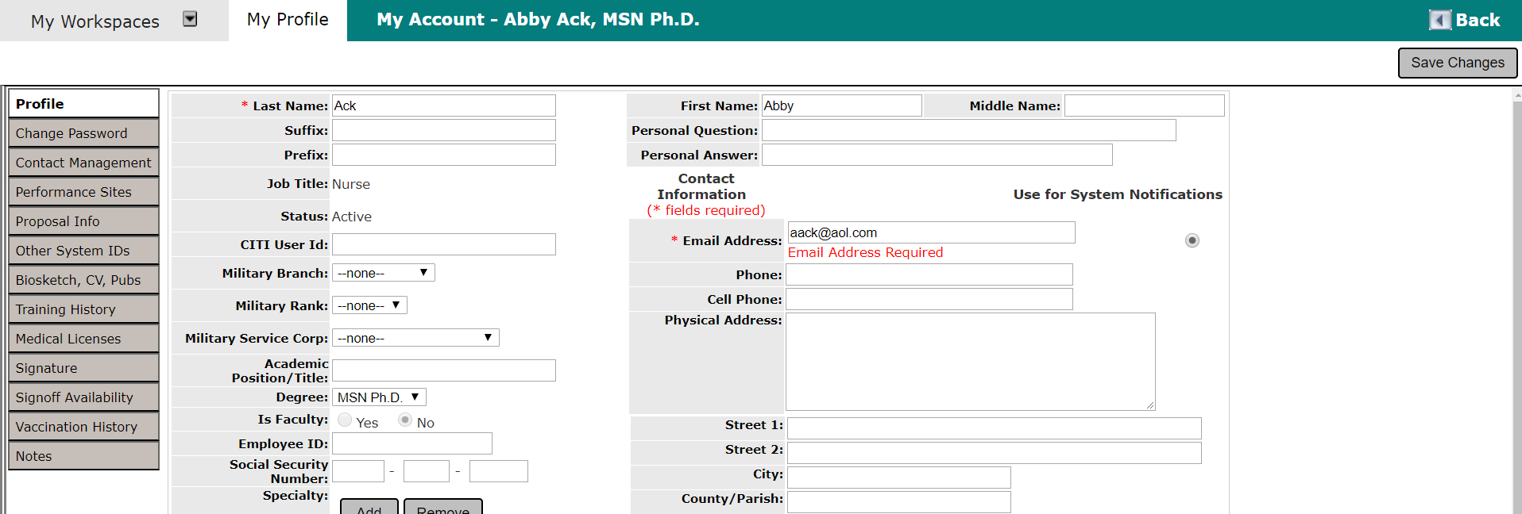

Profile
The Profile tab is where you can view and edit your personal information.
You can change any of the information listed in the screenshot above except for your Department (or Site) association on this screen and your Job Title. This information must be approved and changed by your iRIS™ Administrator. Additionally, some fields like the phone number, email, employee ID, and others may be read-only if your system operates with an LDAP user directory.
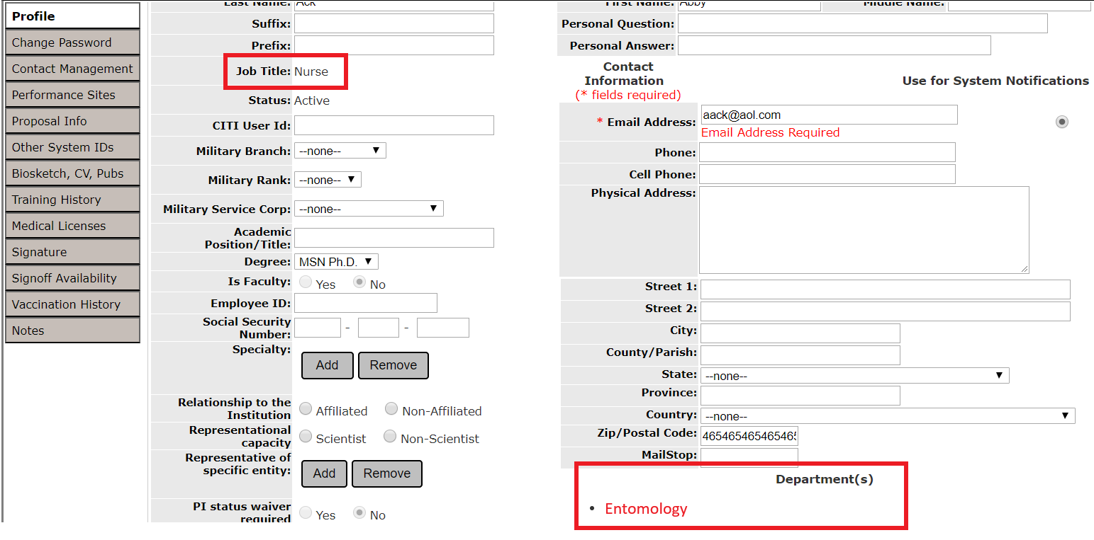
It is now possible to turn off and on the visibility of many of the fields on the Profile tab via system properties, as well as set whether or not they are required. These properties are available under System User Profile Settings.
Two configurable fields are also now available. These fields can be configured under System Administration > List Configuration and Maintenance > System Setup > Setup System Labels. The Configurable Fields appear under the List of Labels for System on the System Label screen.
There are also new editable fields. When the system property “system.use_military_info” is set to “Yes,” you will be able to edit the Military Branch, Military Rank, and Military Service Corps under My Account Information.
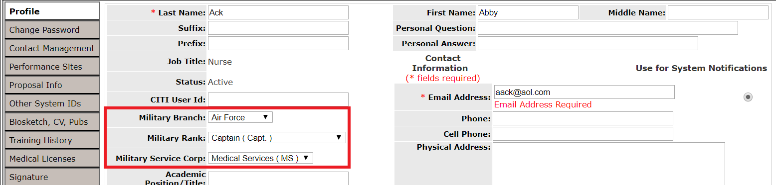
A new property has been added under System Administration > System Configuration > System User Profile Properties that adds another field on the My Account page in My Profile. If you are using CITI at your institution, and the property is turned on, users will be able to add their CITI User ID in a new field.
The property is under System Administration > System Configuration > System User Profile Properties, > system.show_CITI_ID. It will show the new field where users can input their CITI User ID if the property is set to “Yes”. When set to “No”, the user will not be able to see the option to input their CITI User ID.
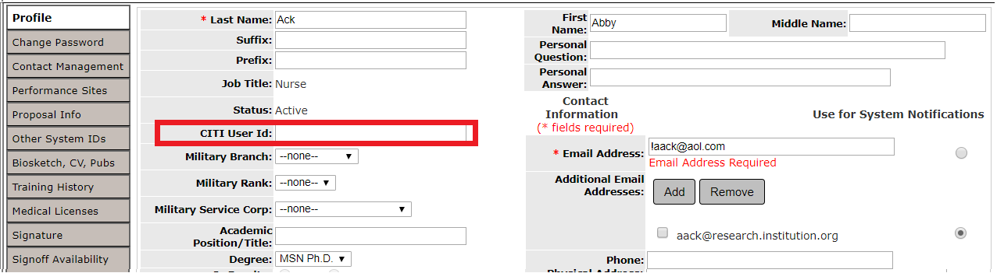
Remember to click on the Save Changes button whenever you make changes to this page. Otherwise, when you exit this page, your changes will not be applied. (Some fields may be designated as required as described above and you cannot click Save Changes until they are entered.)
Note: It is important to have your current e-mail address listed. iRIS™ sends out important notifications regarding your projects. If you do not have your correct email address, you will not receive these notifications.
Additional email addresses can now be stored under a users’ profile in My Profile. System Administrators must turn on the property in order to allow users to have additional email address.
The property is located under System Administration > User Accounts > System Configuration > System User Profile Settings > system.show_addt'l_email_address.
When this property is set to “No”, the option to add an additional email address is not available.
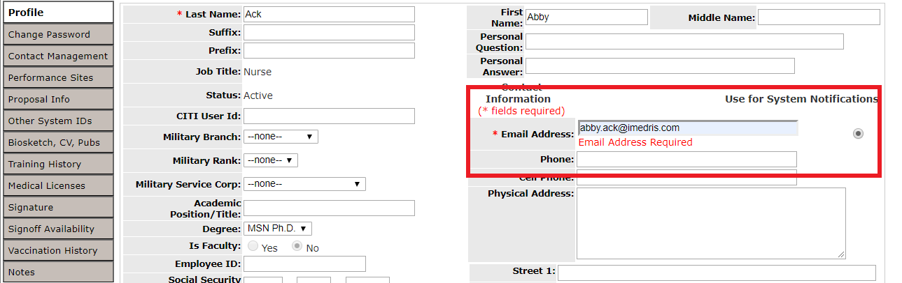
When this property is set to “Yes”, the option to add an additional email address is available under My Profile > My Account.
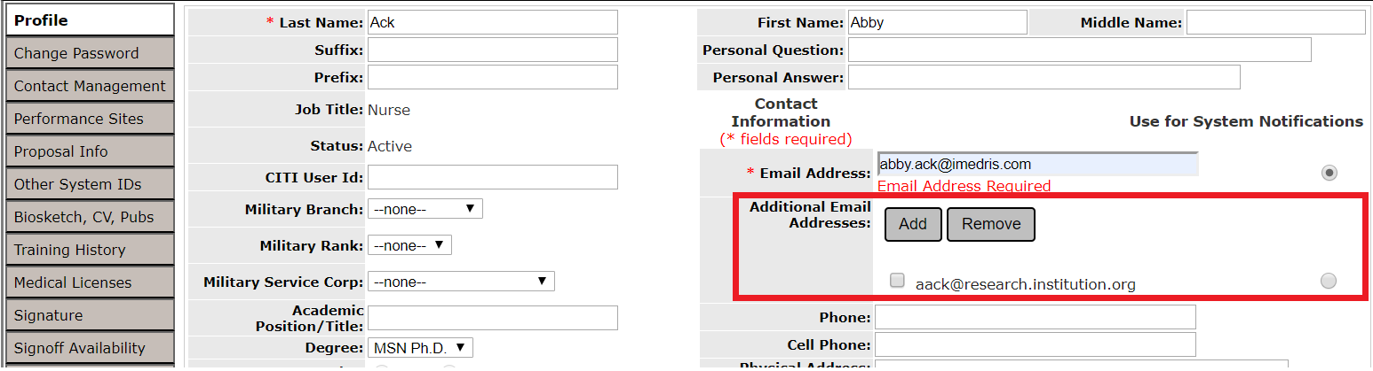
When the button Add is clicked, another pop-up will appear where the administrators or users can add the additional email.
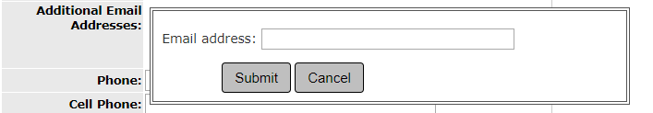
When another user has added another email, the user can set the additional email address as their preferred email address for system notifications by clicking on the radio button.
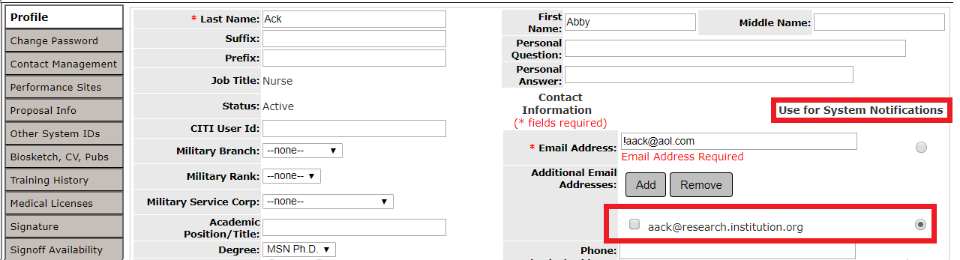
This will change email that the system will send the system notifications to.
Note: The System Administrator has the ability to add customized links to the My Profile tab. The property system.use_custom_menus, within System Administration -> System Configuration -> System Default Settings allows the System Administrator to turn on or off this feature. These links may either be Internal or External. The Internal links will link directly to a page within iRIS.

Change Password
Click on the Change Password tab to change your password.
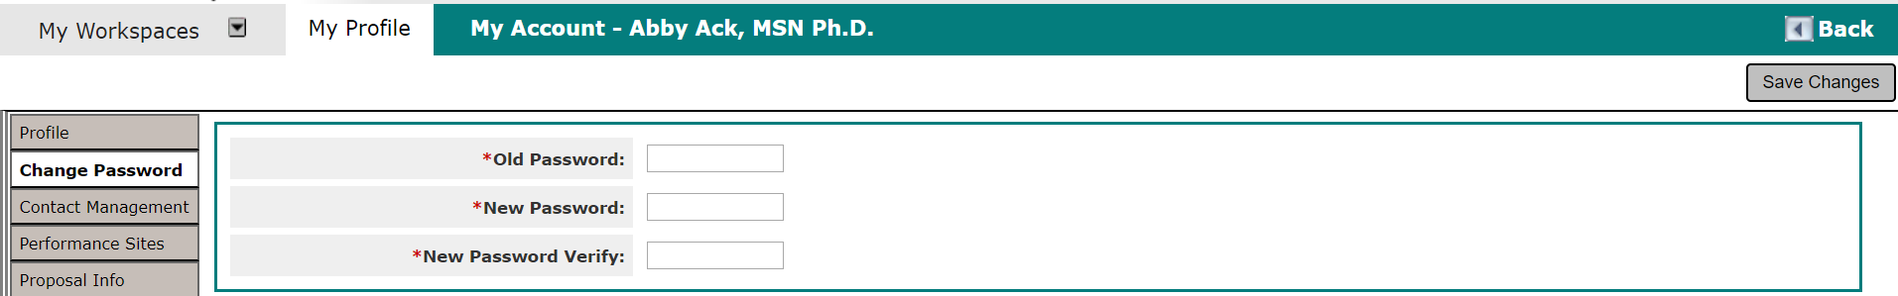
This will open a page similar to the one shown in the screenshot above. In order to change your password, you must supply your Old Password, enter in the desired New Password, and verify the desired New Password in the section New Password Verify. Click Save Changes to complete the change in your password. Your instance of iRIS may have settings that does not allow you to use the last few passwords you have used in the past.

Biosketch, CV, Pubs
You can upload and view your Biosketch, CV, and Publications from this tab.
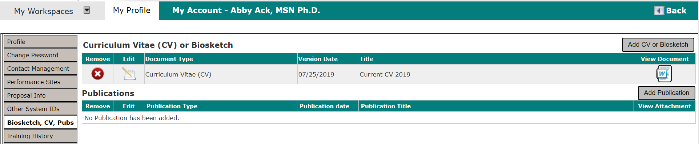
The above screenshot is what your Biosketch, CV, and Publications page may look like. From this page you will be able to upload your professional experience and other relevant work you have conducted. This tab will contain any Curriculum Vitae/Biosketch/Publications you may have stored in iRIS. All three of these documents can be added by you or your System Administrator.
Remove a Document – To delete the CV/Publications record from iRIS, click the button in the Remove Column.
Edit a Document – Clicking the icon in the Edit column opens up the specific, editable details for the document.
Document Type – Category of Document chosen to upload.
Version Date – Date of the uploaded version.
Title – Title of the document uploaded.
View Document – The icon of the document opens a new window that will display the uploaded document.
Add a CV or Biosketch – Click on the Add CV or Biosketch button to open a new page similar to the one shown in the screenshot below.
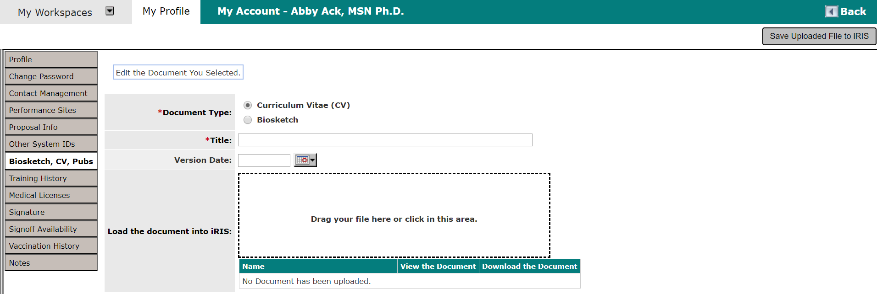
In the above screen shot you can determine which document type you wish to upload. In this particular case, we will be uploading a Curriculum Vitae (CV) so we will select the corresponding button.
Document Type – The type of document being uploaded – either a Curriculum Vitae (CV) or a Biosketch.
Title –The title of the CV (*required field).
Version Date – The version date of the CV.
Load the document into iRIS – Click on the Upload button to upload your CV document into iRIS. The document must be either .doc or .rtf file format in order for iRIS to accept the upload. You can also choose to drag and drop your file into the box outlined in a dotted line.
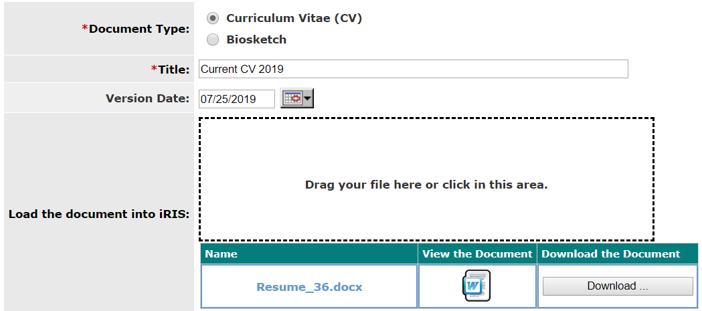
After you upload a document, the page will refresh and a Word icon will populate to the left of the CV information When you are finished adding the information for the CV, click Save Uploaded file to IRIS button and you will be returned to the previous screen.
Click Add Publication and the following screen will appear. Each publication entry can have a Publication Type, Publication Title, and Publication Date. The publication document itself can be loaded as an attachment. Additionally, each publication listing can be associated to a particular project or study and/or certain keywords.
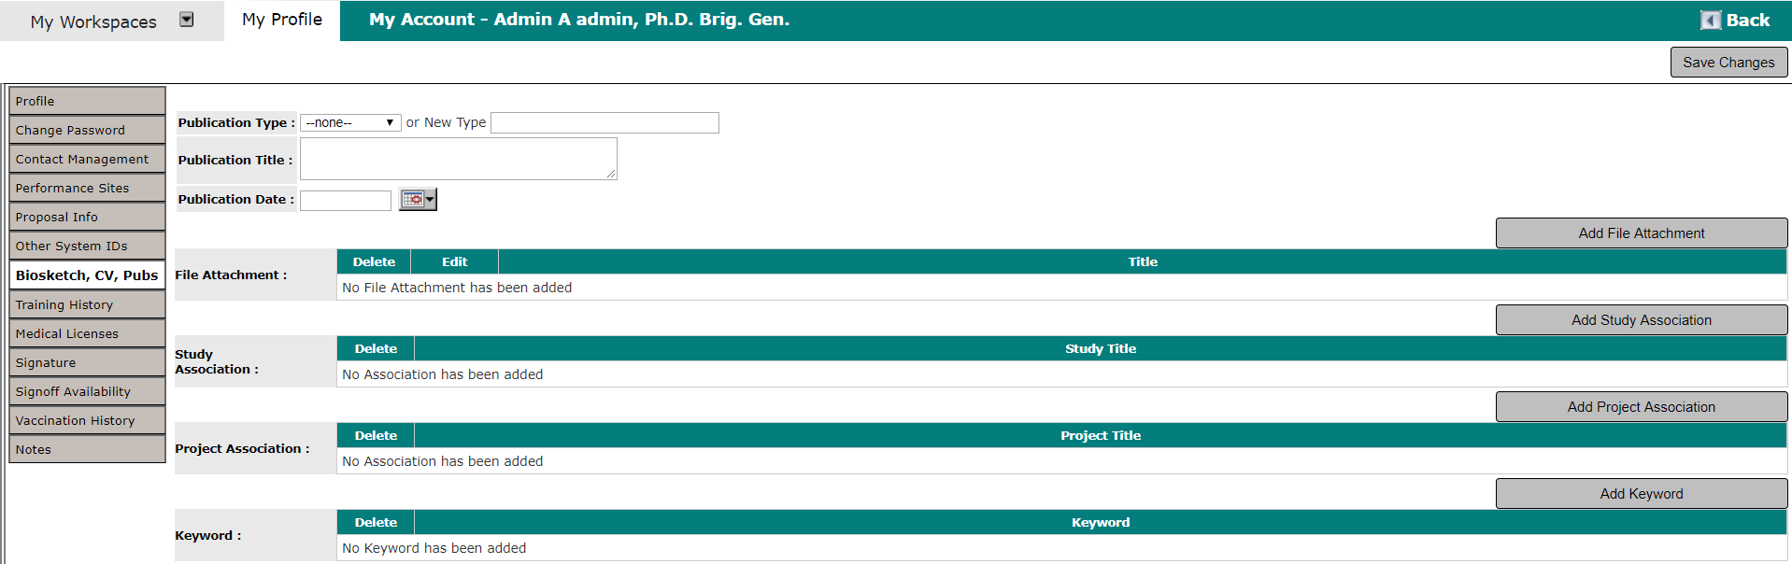

Training History
You can view your training history by clicking on this tab.
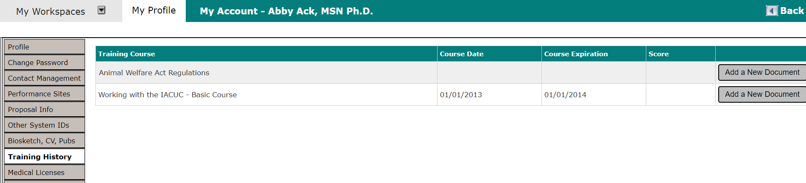
The screenshot above is an example of what the Training History page may look like. The items listed in the table may include: associated Training Group, the Course title, Course Date (the day the training was taken), Course Expiration (date the training expires), and the Score received for the training. All information must be approved and changed by your iRIS Administrator.

Medical Licenses
Any Medical Licenses you may have can be found in this tab. You and/or the Administrator can upload this information.
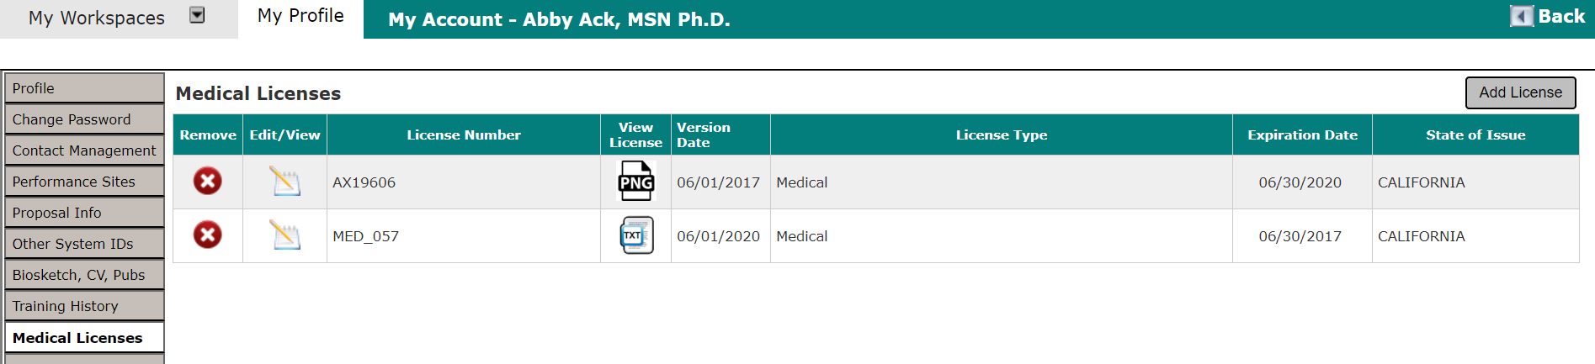
Remove License– To delete a Medical License record, click the icon in the Remove column.
Edit/View – Click on the icon in this column to open up the details for the specific license you wish to view. This is where you can find editable details for the Medical License record and make any necessary changes.
License Number – Number of the License for reference.
View License – Click on the icon in this column to open a document viewer and see the attached document.
Version Date – The version date of the medical license.
License Type – Type of License uploaded.
Expiration Date – Date when the License will expire.
State of Issue – State where the license was issued to the user.
Add License – Click on the Add License button to add a document. This will open a new page like the one shown below:
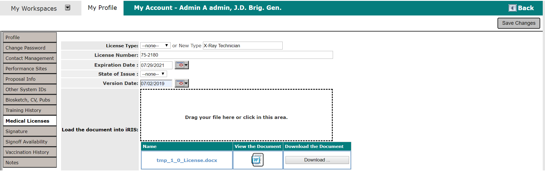
License Type – Select the type of license that you are adding from the drop-down menu or, if not listed, you may add a license type by entering the selection in the New Type text box.
Note: If you enter a New Type, once you save your Medical License, it will be added to the list of License Types and other users will have the option to select it as well. Keep this in mind so that you do not enter personal information in the New Type field.
License Number – The medical license number.
Expiration Date – The expiration date for this specific medical license.
State of Issue – Select the state that issued your medical license from a drop-down list.
Version Date – The version date of the medical license.
Load the document into iRIS – Click Upload and you can attach a document or drag and drop the file into the dotted line box to upload the document.
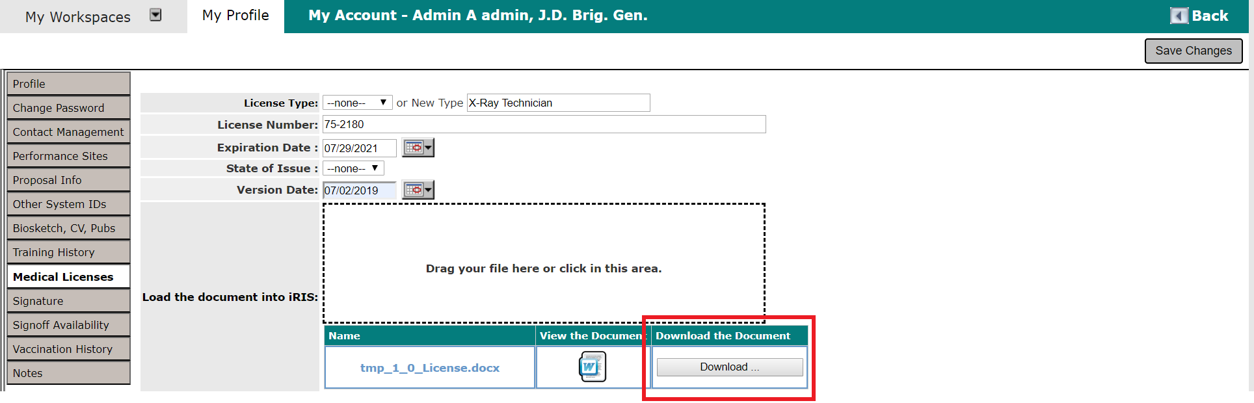
Download the Document – Click Download and confirm by clicking the Confirm button and click Cancel to cancel the download. The file will automatically start downloading. The following screen shows the download function for Google Chrome, other browsers may have a slightly different download function.
When you finish entering information and attaching the required document, click the Save Changes button.

Signature
Users can upload a .jpg of their signature by clicking on this tab, then clicking anywhere in the box with the dotted line to upload the document. You can also drag and drop the file into the box as well to upload the signature.
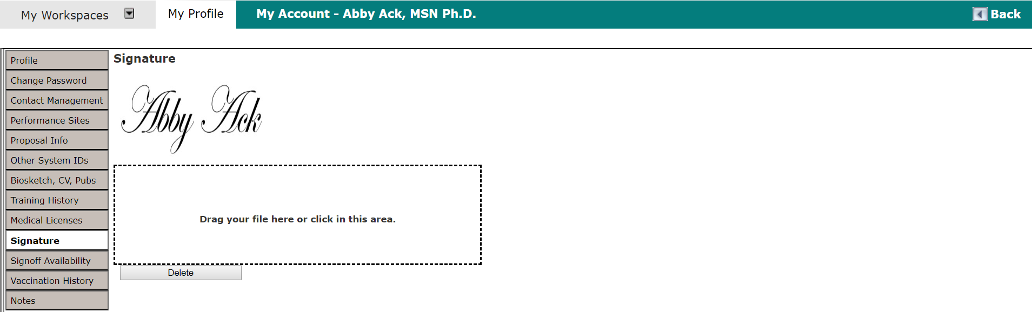
Note: The image that displays on the screen will shrink down to a smaller size when the actual image is applied to a document.
The uploaded signature is used when an electronic signature is applied to an Outcome Letter, or, if configured, to insert department signatures in a PDF version of a submission form. To remove the uploaded signature, click the Delete button.

Notes
Any notes you may have can be found in this tab. You and/or the Administrator can upload this information.
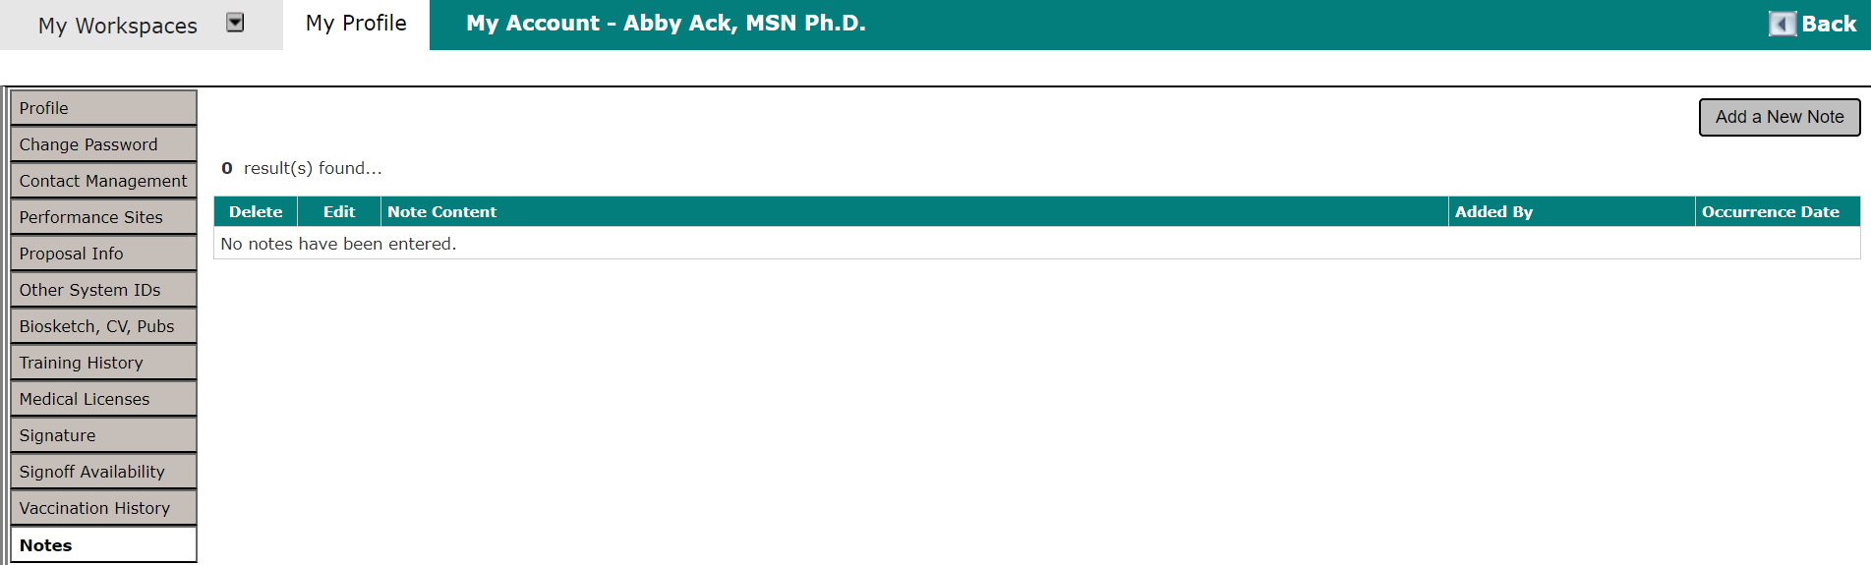
Click Add a New Note to add a new note. The Occurance Date (*required field) must be entered in order to create a new note. Once you have filled in the appropriate text, you will need to click the Save Note button to save the entry. If you do not save the note, the entered text will be lost.
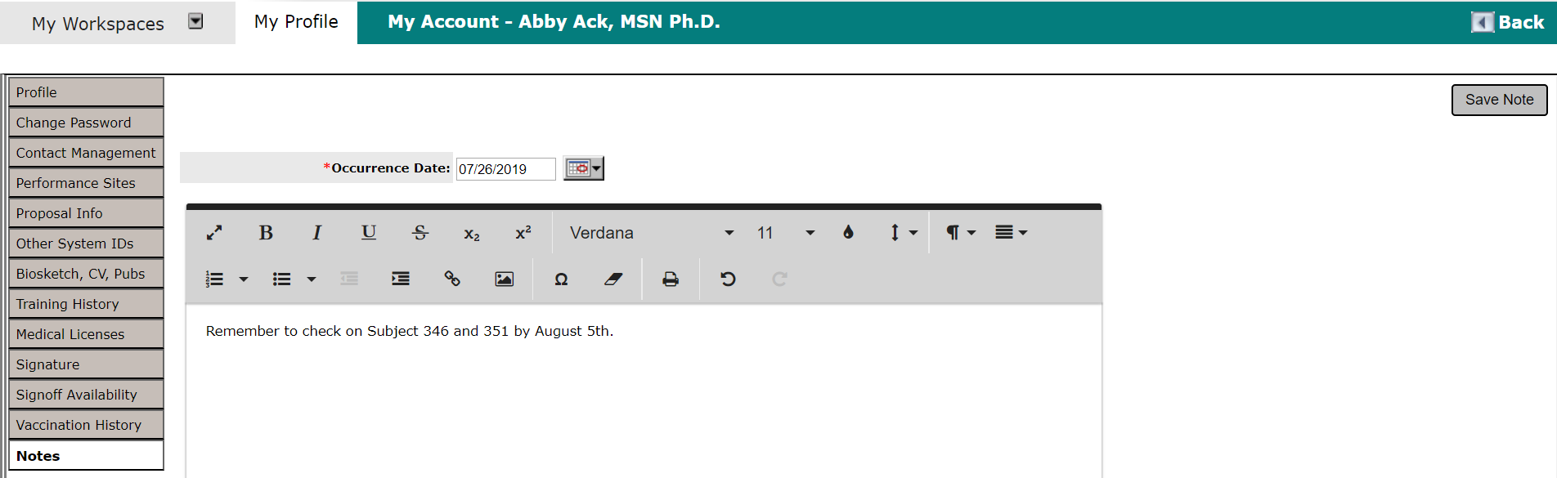
Once the note has been added, you can click the icon to view or make any edits to the published notes. Click the icon in the Delete column to delete a note. This allows the user to delete the requested note.
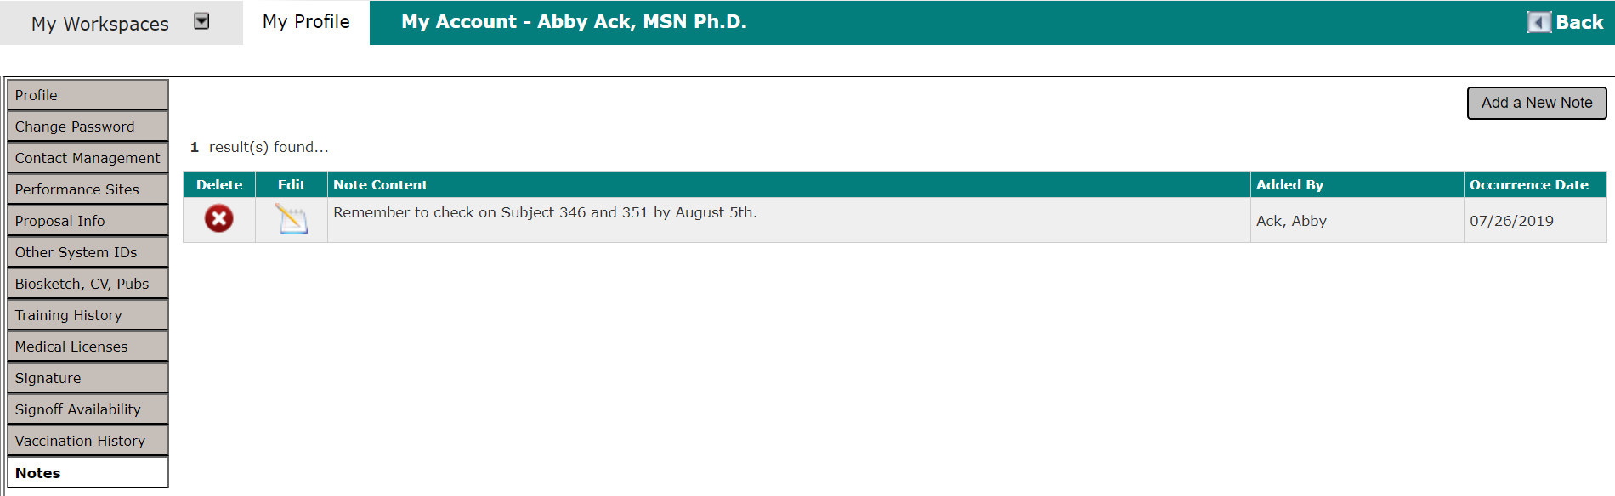

Announcements
When a System Administrator needs to contact every user in the system, they can post an announcement which will appear at the top of the system. The notification will show up as a red pop-up number, indicating how many notifications are there. The user can click on the link which will take the user to view the announcement. Once the announcement has been viewed, the red notification will disappear.
Clicking the link brings you to the System User Announcement screen where you can view the announcement.
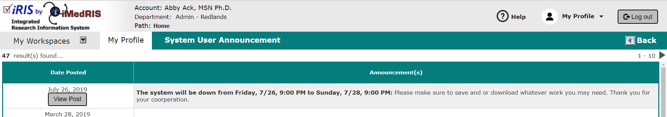
You can view all of the current system announcements by clicking on the Announcements tab under My Profile, or by clicking on Announcement link on the top.
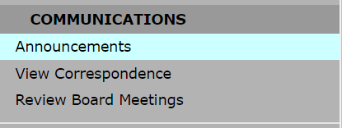
Clicking on the View Post button will bring up a new browser window (as shown in screenshot below). You can Close or Print this message by clicking on the appropriate buttons.
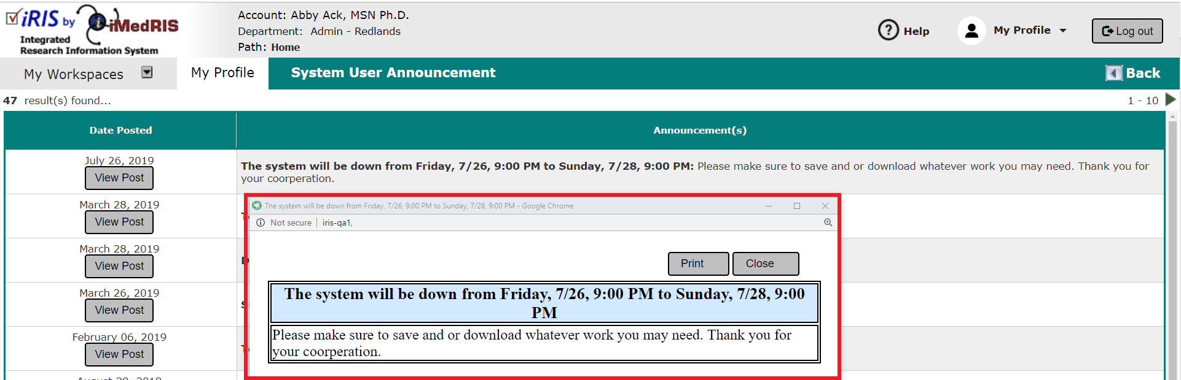

Operating Procedures
This section is used for your site’s Standard Operating Procedures (SOP’s). It is located under the Help section. Each site will have a different list of procedures. Different options are possible depending on the setup of this page.
Link to a Website – The SOP can be linked to a website within your network or to an outside web page (i.e. OHRP.com, FDA.com). The software will automatically open up a new browser window.
Link to Text – If the SOP is documentation not on a website, it might be captured as a text file. This will also load in a new browser window for your convenience.
Link to Attached Document – Typically this is a PDF upload of the SOP. This will also open in a new window.
To view an SOP, click on the link. The SOP will open in a new browser window.
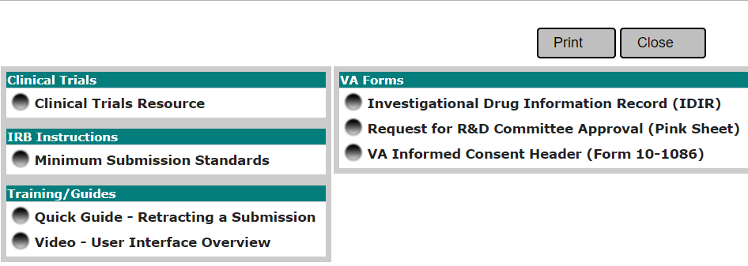

View Correspondence
When you receive correspondence from iRIS, generated from a notification or sent from the review board or study team, it is available for viewing under the View Correspondence link.
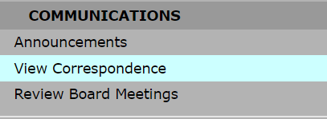
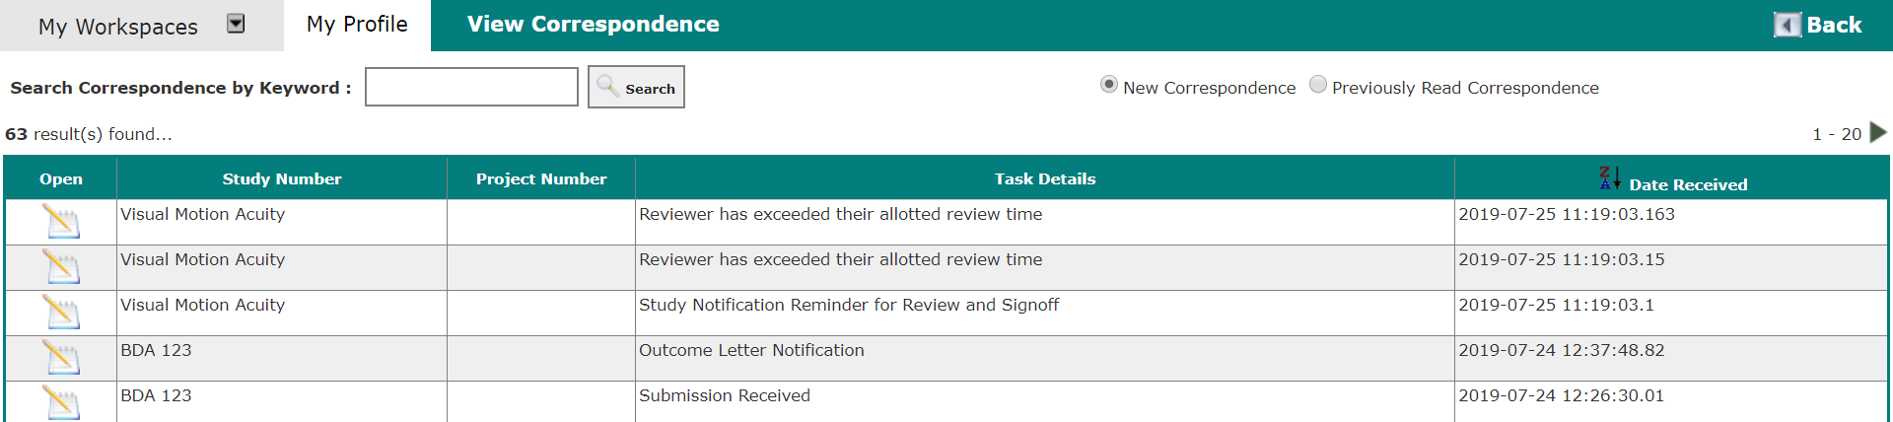
From the View Correspondence screen, you can search for correspondence by keyword. Enter your search terms in the Search Correspondence by Keyword field and click Search.
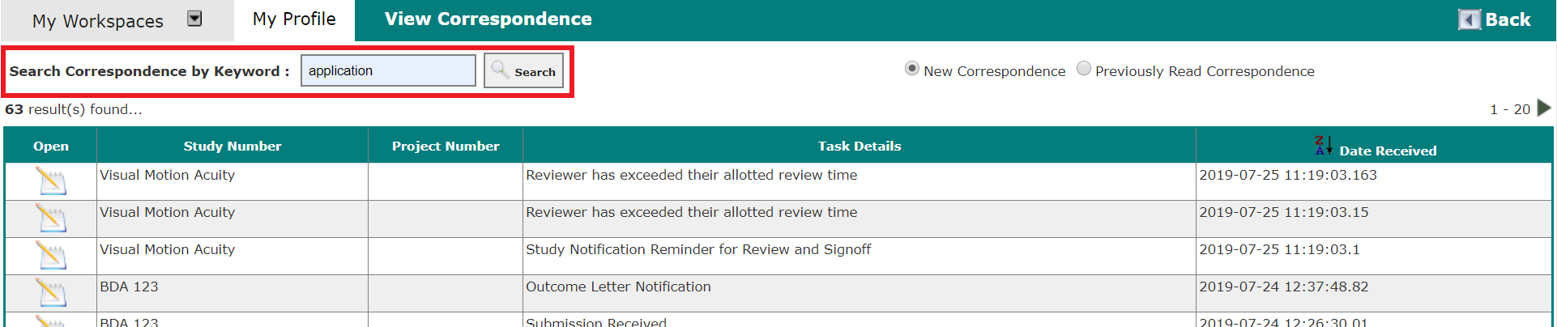
You can toggle between “New Correspondence” and “Previously Read Correspondence” by selecting the corresponding radio button. Once a Correspondence has been read, it will move into the “Previously Read Correspondence” filter.
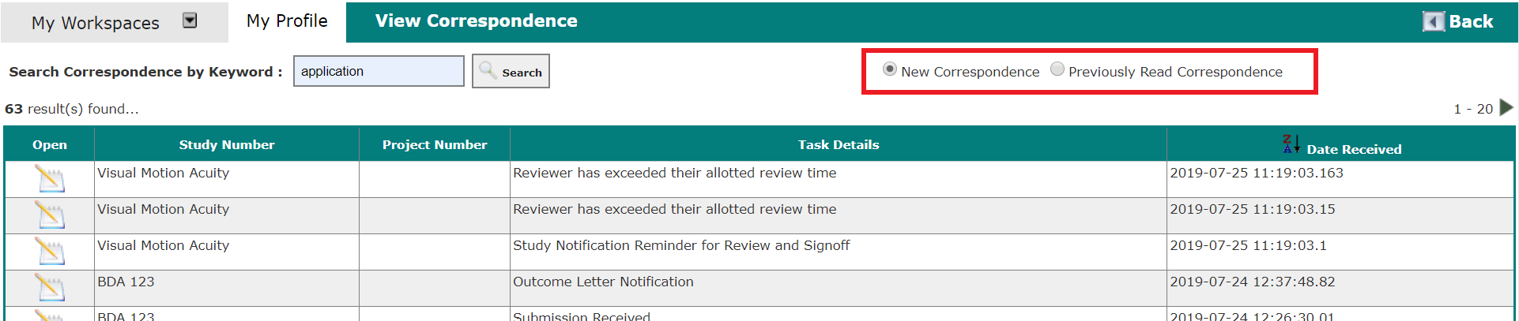
To view the details of a message, click the icon in the Open column. This will open a screen similar to the one shown below.
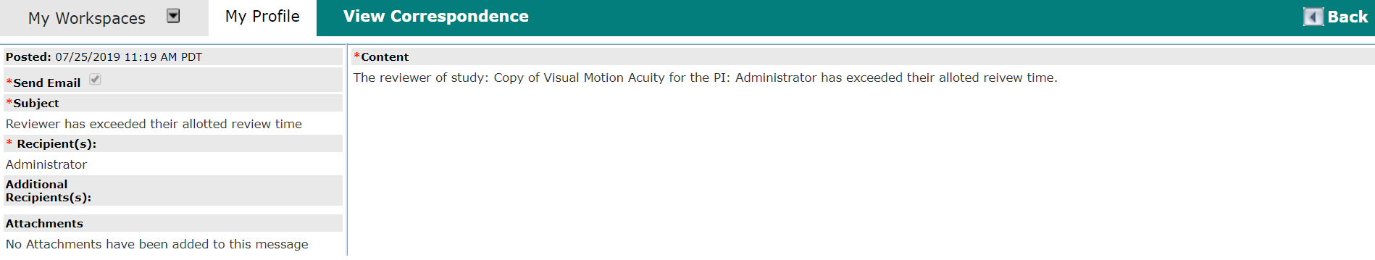

All Department Reports
This section is for your site’s All Department Reports. You will be able to run reports based off of numerous criteria, falling into categories including Financial Tracking, General, License, Studies by, Subject Tracking, Subject Tasks, Submission Tracking, and User’s Schedule. The System Administrator has the ability to give access to other reports if needed – please contact your System Administrator if you would like to add or remove access to a certain report.
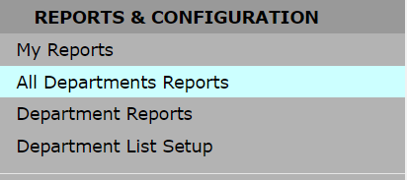
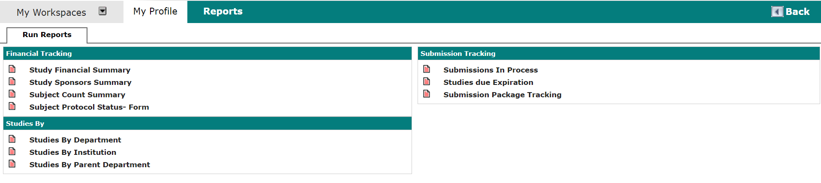
Above is a screen shot of what the all department reports may look like. To run a report, you should select the report you would like to run. We will run a “Studies by Department” report under the “Studies By” header.
In the above screenshot, the user will be given the option to display the report as a PDF, HTML or Excel file. The user will also be able to select the Department/Site Name, Department/Site Code, School Code, and Study Status parameters for the reports. Next, click the Run Report button. The report will then be created and will appear in another window and will be available to be downloaded.

Department Reports
This section is to run department-specific reports. This section is very similar to All Department Reports. When a user is associated with more than one department, they will need to toggle between departments to run reports for each. This can be done on the home screen by selecting Change your Department.
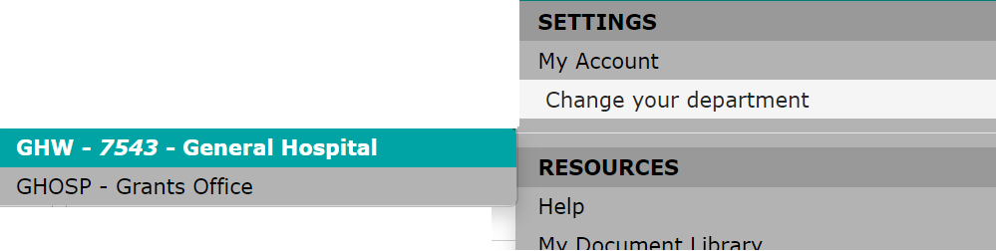
Selecting a default department is required for running department reports. Click on the department you wish to have set as your default.
Below is a screen shot of what the department reports may look like, again, these options are controlled by your System Administrator. Select the report you wish to run. As an example, we will run a “Studies by Status” under the “Studies by” header. Click the “Studies by Status” link.
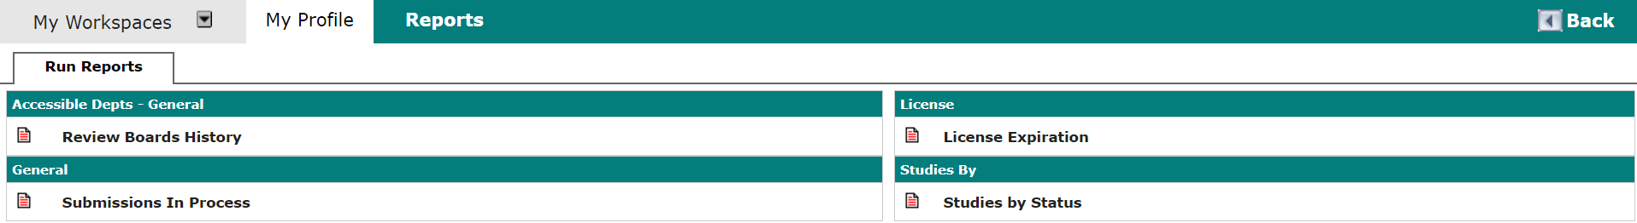
In the below screenshot, the user will be given the option to display the report as a PDF, HTML, or Excel file. The user will also be able to select a Study Status parameter to run reports on only the chosen status. Run the report by clicking the Run Report button. The report will then be created and will appear in another window and will be available to be downloaded.

